Churn Prediction Model – Final Report
1. Overview
A comprehensive churn prediction study was conducted using the Churn Modelling dataset. The primary objective of this analysis was to identify customers who are likely to exit the company so that proactive retention strategies can be implemented.
A total of six machine learning models were trained, tested, and evaluated to determine which model performs best for predicting customer churn.

2. Model Performance Summary
Logistic Regression – Accuracy: 78%
Logistic Regression showed decent performance in identifying churn patterns. However, since it is a linear model, it struggled to capture the complex non-linear relationships present in the dataset.
Decision Tree – Accuracy: 80%
The Decision Tree model provided simple interpretability and reasonable accuracy. However, due to its tendency to overfit, it did not perform as well as the ensemble models.
Support Vector Machine (SVM) – Accuracy: 77%
The SVM model displayed the lowest performance among the six models. While SVM works well for specific types of data, it requires extensive parameter tuning and is not ideal for larger datasets without careful optimization.
Random Forest – Accuracy: 85%
Random Forest performed strongly, benefiting from its ensemble nature and ability to model complex interactions between features. It delivered stable and reliable results.
AdaBoost – Accuracy: 85%
AdaBoost matched Random Forest in performance. The boosting technique helped improve weak learners and captured moderately complex data patterns effectively.
XGBoost – Accuracy: 86% (Top Performing Model)
XGBoost achieved the highest accuracy among all models. It handled complex interactions, imbalanced classes, and non-linear relationships efficiently, making it the best candidate for deployment, so we built the main app on this model.

3. Key Findings
- XGBoost is the most accurate and robust model, achieving an accuracy of 86% and outperforming all other models.
- Ensemble models (Random Forest and AdaBoost) performed significantly better than single models such as Logistic Regression and SVM.
- Customers with lower tenure, higher balance, or specific geographic patterns showed higher churn tendencies.
- The dataset revealed meaningful behavioural indicators that can be used to design customer retention strategies.

4. Business Insights & Recommendations
Retention-Focused Insights
- Customers with low engagement or shorter tenure are more likely to churn—these customers should be targeted with onboarding and loyalty programs.
- High-balance customers, despite contributing more value, may still churn; creating personalized financial advisory or privilege plans may reduce this risk.
- Customers with multiple products tend to stay longer. Cross-selling suitable products can help decrease churn.
- Geographic regions showing higher churn should be analyzed further to understand local dissatisfaction drivers.
Operational Recommendations
- Deploy the XGBoost model in the company's CRM system for real-time churn prediction.
- Build targeted marketing campaigns focusing on high-risk customer segments identified by the model.
- Introduce feedback loops to continuously update the model using new customer data.
- Create proactive engagement strategies for at-risk customers such as early follow-ups, personalized offers, and service quality improvements.

5. Conclusion
This churn prediction project successfully identified the best-performing machine learning model for predicting customer attrition.
XGBoost, with an accuracy of 86%, stands out as the most reliable model for production deployment.
By integrating this model into the business workflow, the company can substantially reduce customer churn, enhance retention efforts, and improve overall customer satisfaction.
App final look
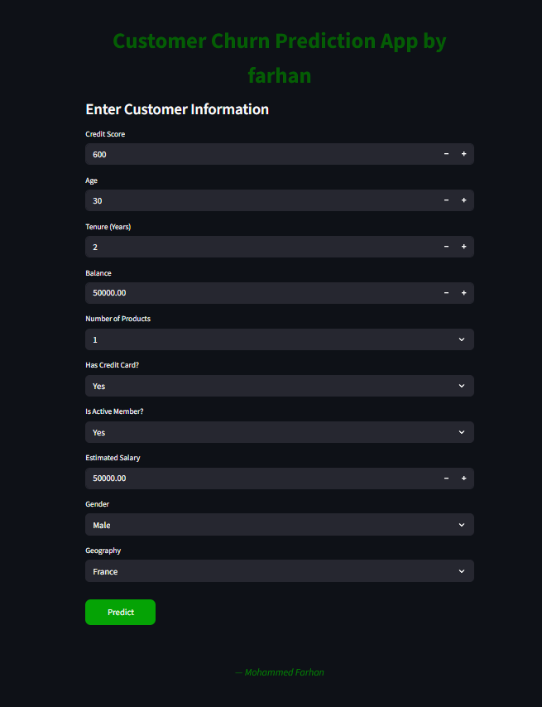
Link:
http://192.168.0.150:8501

